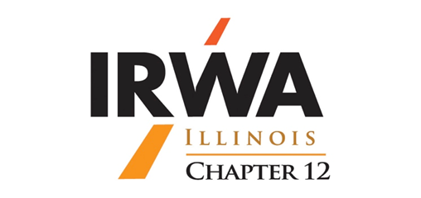

Chapter 12 Fall Business Meeting
Thursday, November 9, 2017

11:00 – 11:30 a.m. Meet and Greet/ Chapter Business

11:30 – 12:00 p.m. Lunch

12:00 – 5:00 p.m. Speaker Presentations by:
Dan Field -- Negotiation
Bill Abernathy – Surveying
Stephen Gardiner- Wind Energy Development
Norm Sim- America’s Newest Generation-The Millennials
Brian Bottomley- Engineering and the Law

6 Hours of Continuing Education for IRWA Recertification
6 Hours of Continuing Education for Appraisers (Pending)

Meeting & Social Event will take place at Illinois Department of Natural Resources

1 Natural Resources Way

Springfield, IL 62702

https://www.dnr.illinois.gov/about/offices/Pages/default.aspx

Please join us for the IRWA Illinois Chapter 12 fall business meeting and social event hosted by 1st AEROW Valuation Group.

(Please RSVP to Bill McIntyre by Wednesday, October 31st)

This event is free to all IRWA members

